**How to look up policy forms**

Log in to RLI’s portal at **myportal.rlicorp.com**using your registered E-mail and Password. Once logged in click the Personal Umbrella drop down. Then click on “Policyholder Forms Activity”.

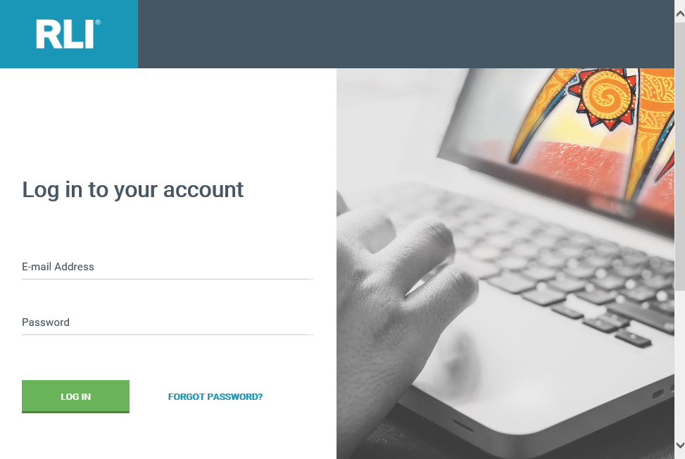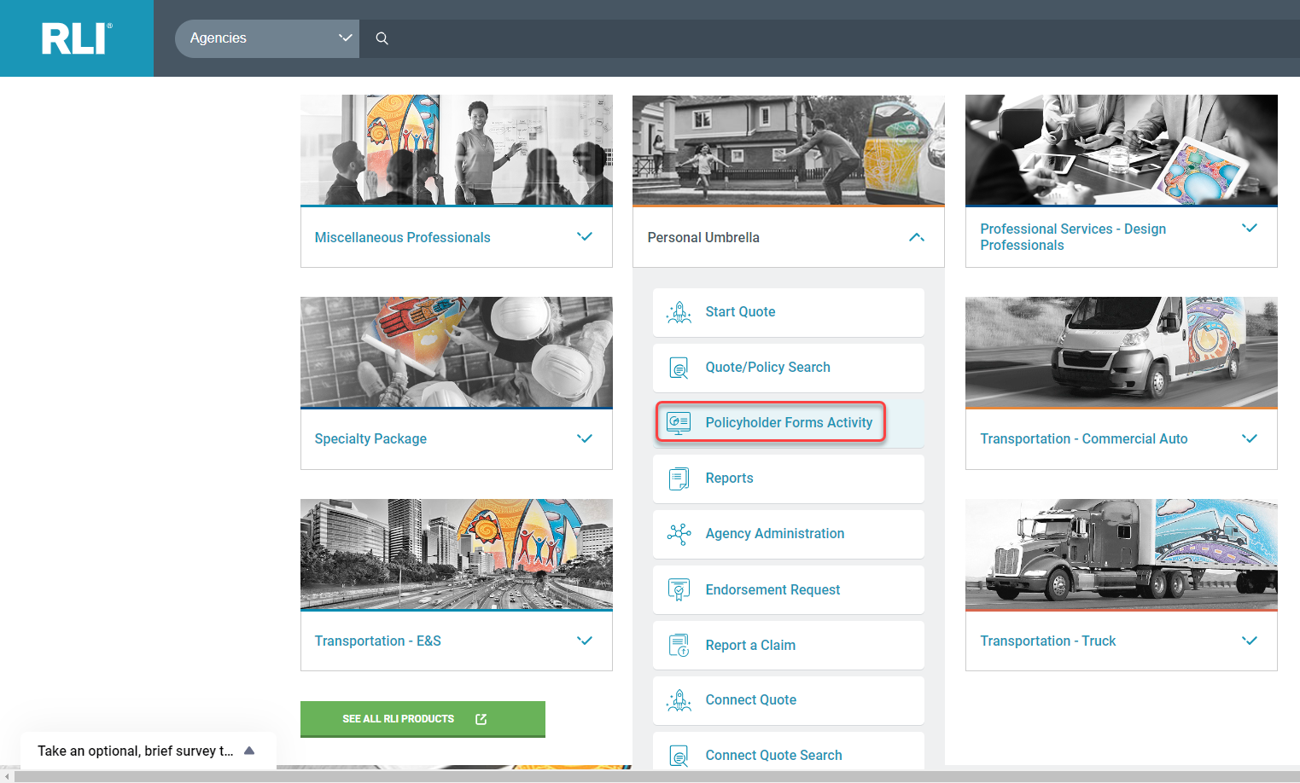

To find the specific quote or policy, enter your quote or policy search criteria and click “Search.”

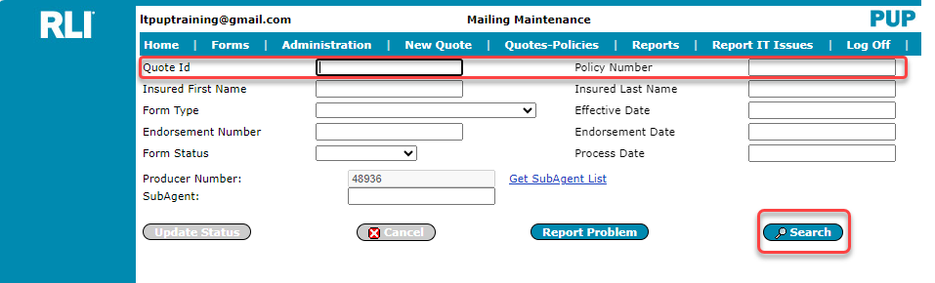

To open a form, click on the appropriate document icon.

